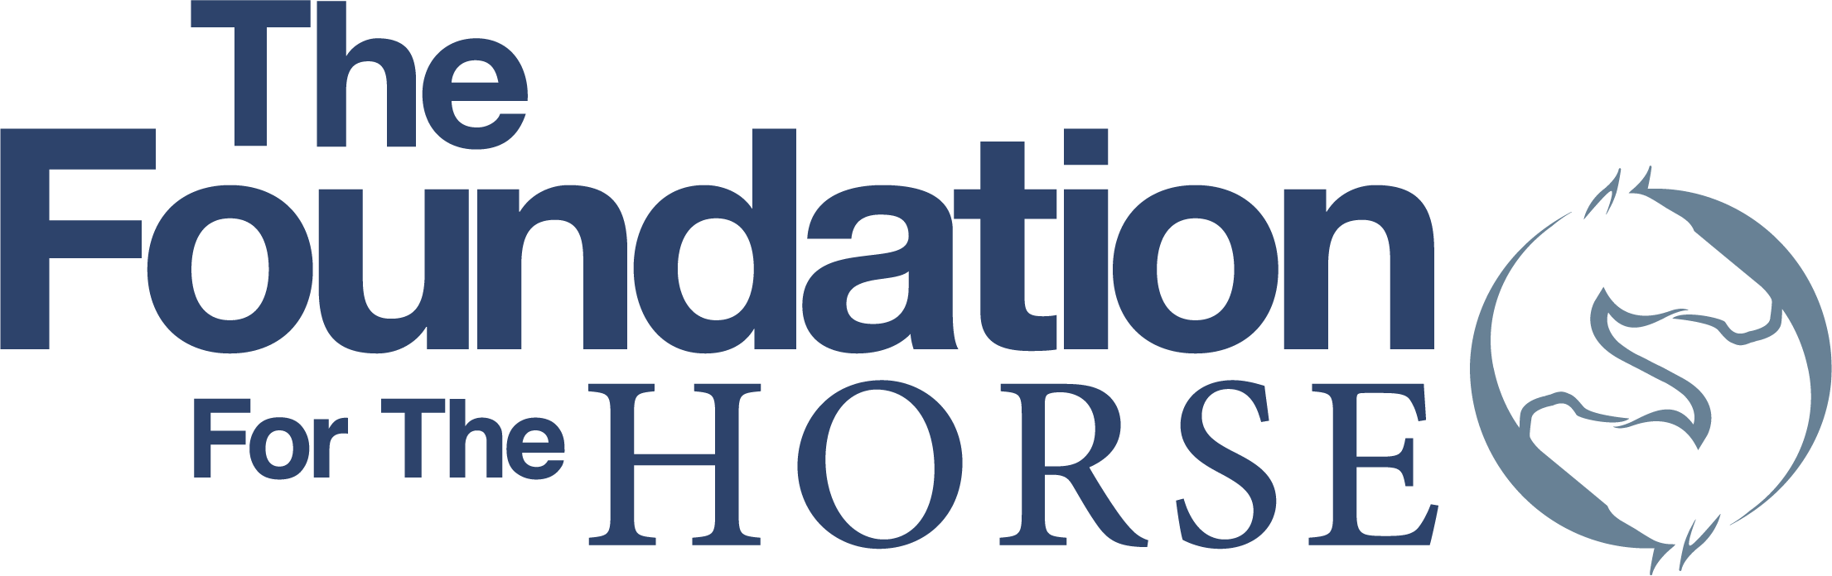
4033 Iron Works Parkway - Lexington, KY 40511
Phone: 859-233-0147 - Fax: 859-233-1968
www.foundationforthehorse.org

FUNDING APPLICATION FORM
For Working Equid Projects

Electronic submission only, Word is preferred, PDF accepted
The completed application form with supporting documents should be submitted to: Elaine Young at eyoung@foundationforthehorse.org

Deadline: June 30, 2021 (11:59 pm PT)

Project Title:

Name of Organization:

Organization’s Mission Statement:

Year Founded:

Name of individual (Must be primary contact for the requesting organization):

Relationship of individual with organization for which funds are requested:

Total amount of funding requested: $

Date funds are needed by:

AAEP-Member Veterinarian Reference and Endorsee (Name and Phone Number):

Programs that benefit working equids of the world, particularly those that are found in impoverished areas, may be supported, and should meet the following criteria:
Programs must include at least three of the following:
- Teams of veterinarians that travel to areas of working equids to perform preventive medicine and therapy for working equids.
- Teams of veterinarians that travel to areas of working equids to educate owners of said animals in their care and use (this includes the Indian reservation work in the US and foreign countries).
- Teams of veterinarians that travel to 3rd world countries to educate veterinarians and veterinary students of those countries.
- Educational conferences for veterinarians performing clinics for working equids.
- Students and veterinarians traveling to 3rd world countries to learn about problems and practice managing medical and husbandry problems in such countries.
- Programs that work cooperatively with other global equid welfare programs and that include at least three of the above items within its program.
Preferred Priority Criteria to Consider:

- Priority will be given to programs with the broadest reach and those that work toward sustainability within the population visited and meet other requirements listed within the application instructions.
- Goal to have projects promote and/or be self-sustainable projects in the future (i.e. “Teach people to fish, not feed them fish”).
- Include educational elements within programs to support sustainability.
- Projects work towards sustainable funding models.

Provide a brief description of this request and describe how funds for this project will be used to directly impact the well-being of working equids and their owners.

Budget: Provide a detailed budget of the project’s expected expenses including a total of the overall anticipated funding requirements. Please use the attached Project Budget Form in Excel!

NOTE: The Foundation DOES NOT fund capital equipment requests. The Foundation may provide capital equipment funding if there is specific, designated program oversight as to where the equipment will be kept, who will use it, and how it will be maintained.

The Foundation DOES NOT fund travel expenses unless it is for in-country travel support or for veterinary student or recent veterinary graduate scholarship support.

List all other sources of funding (for this project), including grants or donations by other individuals, expenses – including pro bono by participating veterinarians, corporations or charitable organizations and the amount contributed by each source.**

Date(s) and location(s) of the program to be funded:

Target audience and/or population served:

How will a grant for this project impact future efforts? Is this grant part of a sustainable program? How will this grant contribute to sustainability of the program? If this is an ongoing program that The Foundation may have funded previously, how this effort may be different and/or complimentary to previously funded programs.

Overhead/Indirect Costs:
Please be informed that The Foundation does not pay for overhead or indirect costs for research or project grants.

Organization Contact for this Application:

Phone number:

FAX number:

Email address:

Mailing Address:

Website address:

EIN /Tax ID #

[ ] IRS letter confirming 501 (c)(3) tax-exempt status** (Please attach)

** Supporting documents may also be attached to the same email used for the application form. PDF preferred.

The completed application form with supporting documents should be submitted to: Elaine Young at eyoung@foundationforthehorse.org

Grant Application Deadline – June 30, 2021 (11:59 pm PT)

