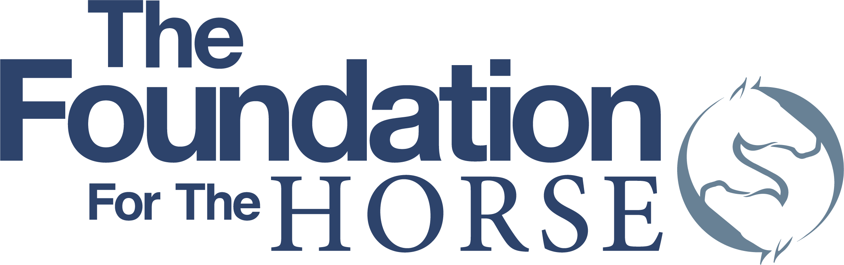
4033 Iron Works Parkway - Lexington, KY 40511
Phone: 859-233-0147 - Fax: 859-233-1968
www.foundationforthehorse.org

FUNDING APPLICATION FORM

Electronic submission only, Word is preferred, PDF accepted
The completed application form with supporting documents should be submitted to: Elaine Young at eyoung@foundationforthehorse.org

Deadline: June 30, 2021 (11:59 pm PT)

Project Title:

Name of Organization:

Organization’s Mission Statement:

Year Founded:

Name of individual (Must be primary contact for the requesting organization):

Relationship of individual with organization for which funds are requested:

Total amount of funding requested: $

Date funds are needed by:

AAEP-Member Veterinarian Reference and Endorsee (Name and Phone Number):

The request will support which The Foundation’s mission areas (circle one or more)?

Education Research Benevolence

Provide a brief description of this request and describe how funds for this project will be used to directly impact the welfare of horses in the designated Foundation mission area of Education, Research and or Benevolence.

Budget: Provide a detailed budget of the project’s expected expenses including a total of the overall anticipated funding requirements. Please use the attached Project Budget Form in Excel or in your own budget provide similar details.

List all other sources of funding (for this project), including grants or donations by other individuals, corporations or charitable organizations and the amount contributed by each source.**

Date(s) and location(s) of the program to be funded:

Target audience and/or population served:

How will a grant for this project impact future efforts? Is this grant part of a sustainable program? How will this grant contribute to sustainability of the program, especially if this is an ongoing program and/or you have received funding for this program in previous years?

Overhead/Indirect Costs:
Please be informed that The Foundation does not pay for overhead or indirect costs for research or project grants.

Organization Contact for this Application:

Phone number:

FAX number:

Email address:

Mailing Address:

Website address:

EIN /Tax ID #

[ ] IRS letter confirming 501 (c)(3) tax-exempt status** (Please attach)

** Supporting documents may also be attached to the same email used for the application form. PDF preferred.

The completed application form with supporting documents should be submitted to Elaine Young at eyoung@foundationforthehorse.org.

Deadline to apply – June 30, 2021 (11:59 pm PT)

